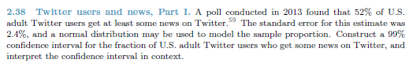

Confidence Interval: (0.52-Z\*0.024, 0.52+Z\*0.024)

(0.52-2.58\*0.024, 0.52+2.58\*0.024)

(0.458,0.582)  
(45.8%, 58.2%)

We are 99% confident that 45.8% to 58.2% of adult Twitter users get some news from twitter.

Confidence Interval (0.45-Z\*0.012, 0.45-Z\*0.012)

Z = +- 1.96

(0.45-1.96\*0.012,0.45+1.96\*0.012)

(42.65%,47.35%)

1. False, you can never be certain with a confidence interval, there is still error based on the confidence interval
2. True, about 95 precent of the studies landed within the confidence interval  
   1000 \* 0.95 = 950
3. True, we are 95% confident that the percentage of adults suffering from conic illnesses is between 42.65% and 47.35% and 50% is not within that range.
4. False, standard error is error of the study as a whole, NOT of an individual.

Confidence Interval: (0.52-Z\*0.024, 0.52+Z\*0.024)

(0.52-2.58\*0.024, 0.52+2.58\*0.024)

(0.458,0.582)  
(45.8%, 58.2%)

1. False, below 50% falls within the range of our confidence interval
2. False, this is our standered error for the study, not the number of people participating in the study
3. False, the more data we have the smaller or standard error will become.
4. False, our interval would be smaller, but we would be less confident